

**Batch: B–1 Roll No.: 16010422234 Experiment No.: 02**

**__________________________________________**

**Aim:**

1. To create a Windows Virtual Machine (VM) instance in AWS using RDP (Remote Desktop Protocol).
2. To create a Linux Virtual Machine (VM) instance in AWS and connect with PuTTY.

**__________________________________________**

**Resources needed: AWS (Amazon Web Services), PuTTY**

**__________________________________________**

**Theory:**

**What is a virtual machine?**

In its simplest form, a virtual machine, or VM, is a digitized version of a physical computer. Virtual machines can run programs and operating systems, store data, connect to networks, and do other computing functions. However, a VM uses entirely virtual resources instead of physical components. VMs enable businesses to create isolated environments on host hardware that behave like separate machines.

**A VM is a virtualized environment of a physical computer. It can perform almost all of**

**the same functions, including running applications and operating systems.**

**How do virtual machines work?**

Virtual machines use virtualization technology to create virtual hardware—or a virtual version of a computer on a physical machine. The physical machine on which the VMs run is called the host, and the VMs running on the host are called guests. Each guest VM runs on an isolated partition on the host, completely separated from other guests. You can host multiple VMs on a single host machine, often a server, running on a software layer known as the hypervisor. The hypervisor abstracts the host machine’s physical resources, such as compute, memory, or storage, into a pool that can be provisioned and dynamically allocated to guest VMs as needed, providing more flexibility and increasing overall efficiency.

**IaaS (Infrastructure as a Service):** AWS EC2 (Elastic Compute Cloud) is a cloud-based IaaS offering that provides scalable compute resources. It allows users to create and manage virtual machines (VMs), known as EC2 instances, with various configurations based on performance and resource needs.

**Amazon EC2 (Elastic Compute Cloud):** EC2 instances are virtual servers in AWS, where users can run applications, store data, and access computing resources as needed. EC2 instances can be configured with different operating systems, including various versions of Windows.

**Windows AMI (Amazon Machine Image):** AWS provides pre-configured machine images for different operating systems, including Windows. A Windows-based AMI will be used to create the VM instance.

**RDP (Remote Desktop Protocol):** RDP is a protocol used to remotely access Windows-based computers. It allows users to control the desktop of the instance as if they were physically present, making it ideal for managing Windows servers and applications.

**Linux AMI:** Just like for Windows, AWS provides pre-configured Amazon Machine Images (AMIs) for Linux-based operating systems, such as Ubuntu, CentOS, and Amazon Linux. The Linux VM will be based on one of these AMIs.

**SSH (Secure Shell):** SSH is a cryptographic network protocol used to securely connect to a remote machine (Linux in this case) through the command line. PuTTY is used on Windows systems to establish this SSH connection.

**__________________________________________**

**Procedure:**

**1. Launch and connect to a Window instance and execute a simple program.**

**2. Launch and connect to a Linux instance and execute a simple program.**

**__________________________________________**

**Procedure for Windows VM (using RDP):**

1. **Launch EC2 Instance for Windows:**
   1. Log in to the AWS Management Console.
   2. Navigate to EC2 and click on Launch Instance.
   3. Choose a Windows AMI (e.g., Windows Server 2019 or 2022).
   4. Select the instance type based on your requirements (e.g., t3.micro for light workloads).
   5. In the Key Pair section, select or create a new key pair. Make sure to download the .pem file, which will be used to get the administrator password.
2. **Configure Networking and Security:**
   1. Set up a Security Group to allow inbound RDP traffic:
   2. Open port 3389 (default for RDP) and allow access from your IP address for security reasons.
   3. Ensure that the VPC and subnet settings are correct for internet access.
3. **Download the RDP File:**
   1. After the instance is created, go to the Instances dashboard.
   2. Select your instance and click Connect.
   3. Under RDP Client, download the RDP file.
   4. Use the Administrator Password (retrieved from the .pem file) to log in to the Windows instance using RDP.
4. **Connect via RDP:**
   1. Open Remote Desktop Connection on your local machine.
   2. Enter the Elastic IP or Public IP of the Windows instance.
   3. Use the administrator password to log in.

**__________________________________________**

**Procedure for Linux VM (Using PuTTY):**

1. **Launch EC2 Instance for Linux:**
   1. Log in to the AWS Management Console.
   2. Navigate to EC2 and click on Launch Instance.
   3. Choose a Linux AMI (e.g., Ubuntu, Amazon Linux, or CentOS).
   4. Select the instance type (e.g., t3.micro).
   5. In the Key Pair section, choose an existing key pair or create a new one. Download the .ppk file directly from AWS (you can skip conversion if the .ppk file is downloaded).
2. **Configure Networking and Security:**
   1. Set up a Security Group to allow inbound SSH traffic on port 22 from your IP address.
3. **Access the Instance via PuTTY:**
   1. Open PuTTY on your local machine.
   2. Enter the Elastic IP or Public IP of your Linux instance in the Host Name field.
   3. Under Connection > SSH > Auth, browse and select the .ppk file that you downloaded.
   4. Click Open to initiate the SSH connection.
4. **Login to the Instance:**
   1. When prompted, log in using the default username for your Linux AMI (e.g., ubuntu for Ubuntu, ec2-user for Amazon Linux).
   2. You will now have SSH access to your Linux instance.

**__________________________________________**

**Results: (Attach the snapshots of execution)**

**Windows Virtual Machine (VM) instance in AWS**

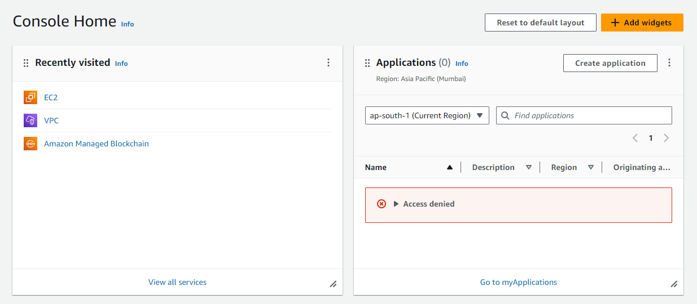

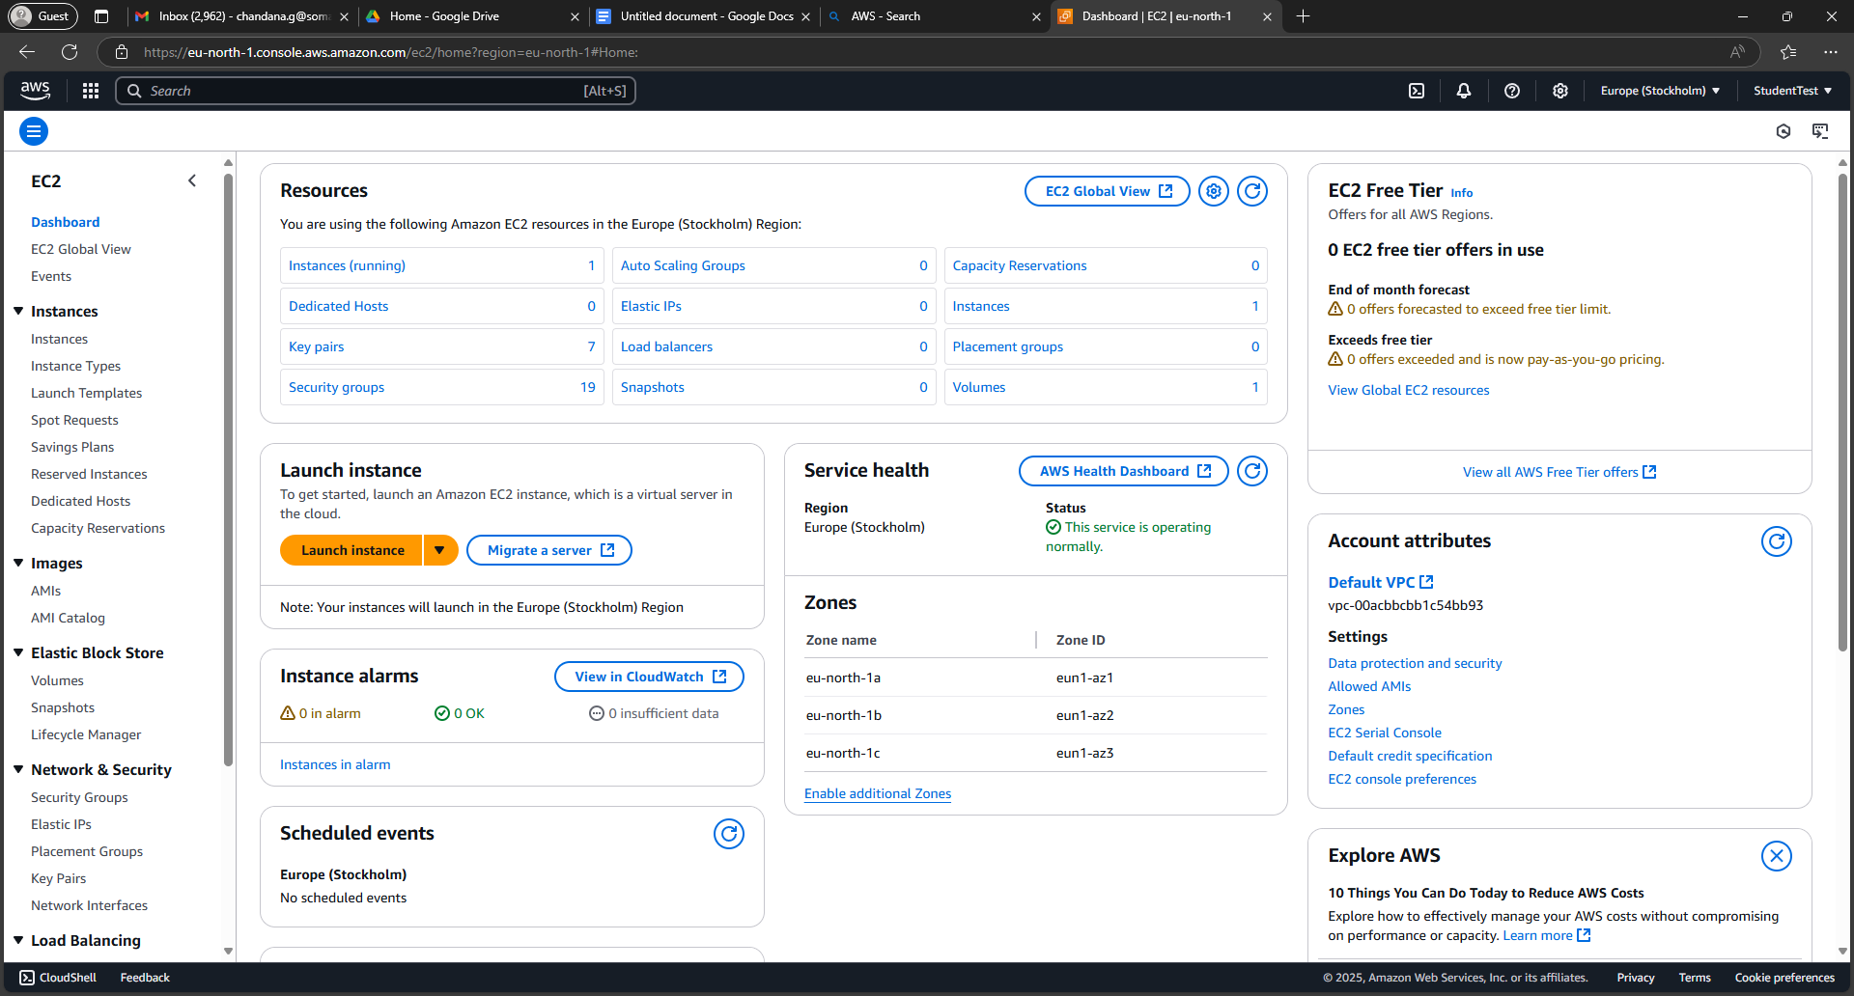

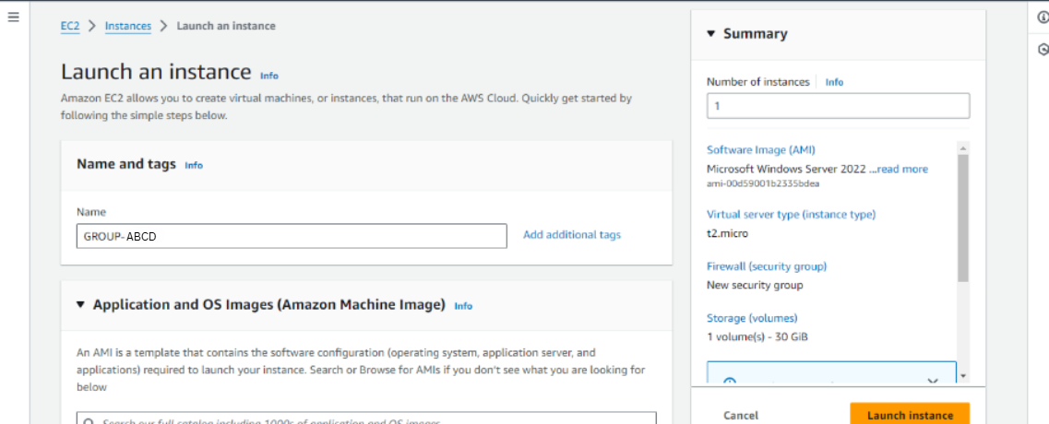

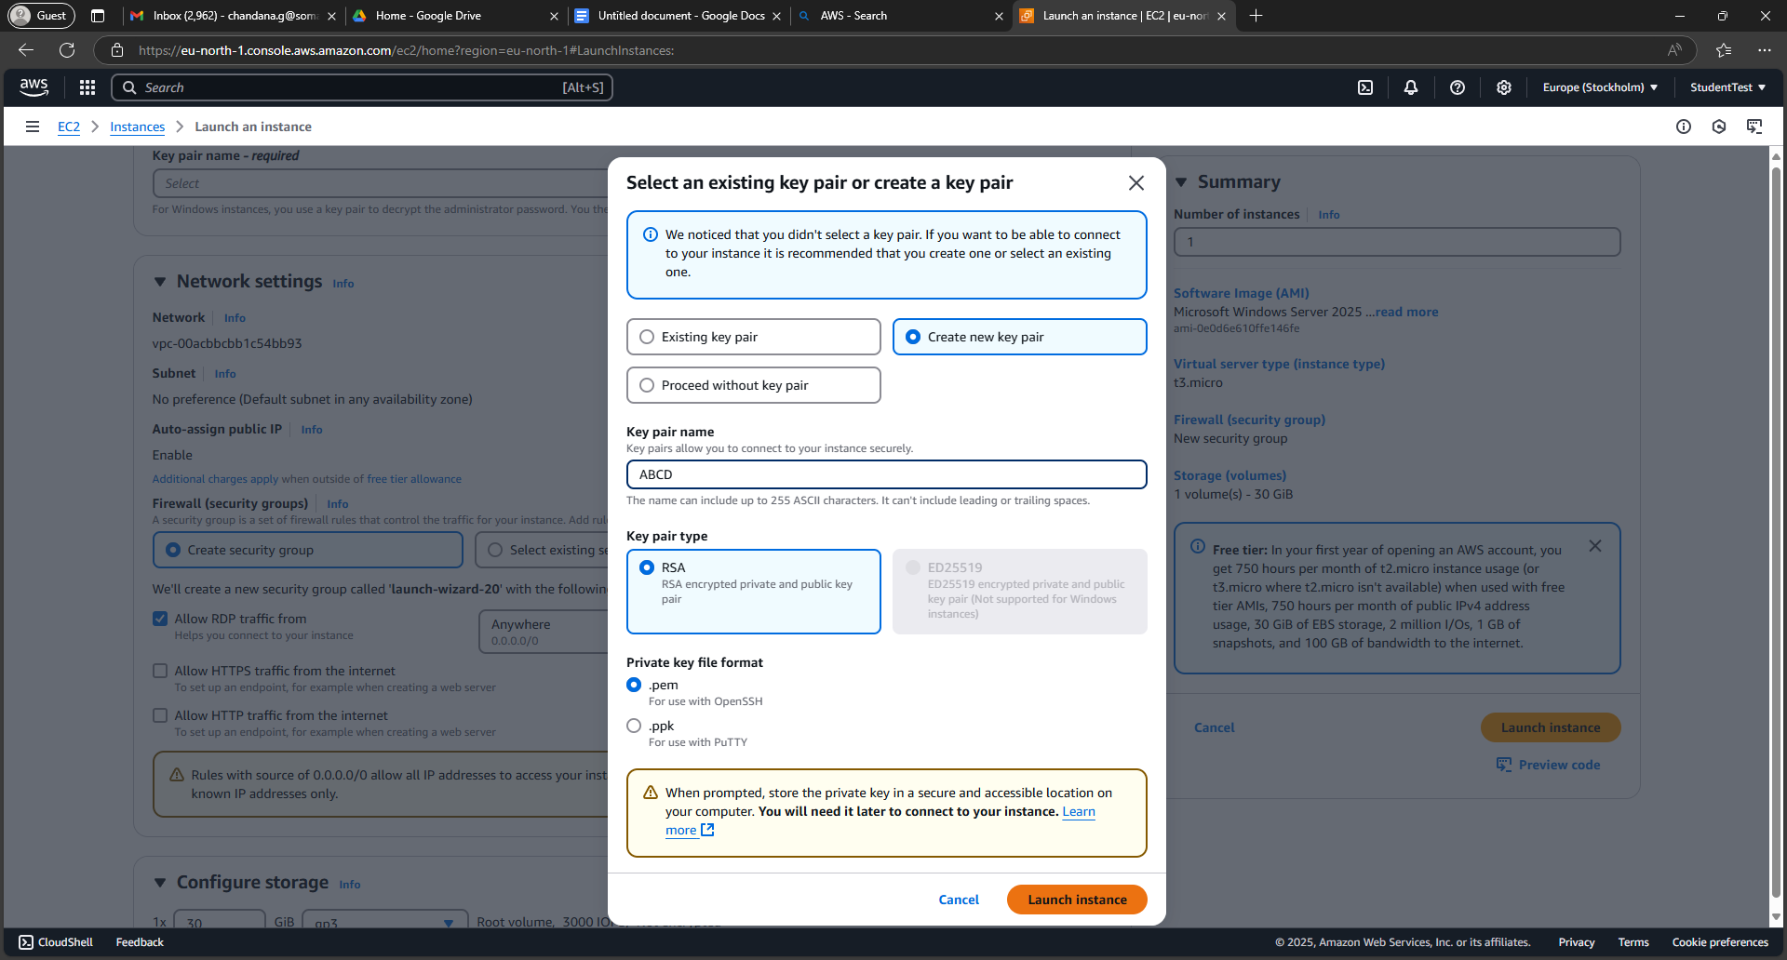

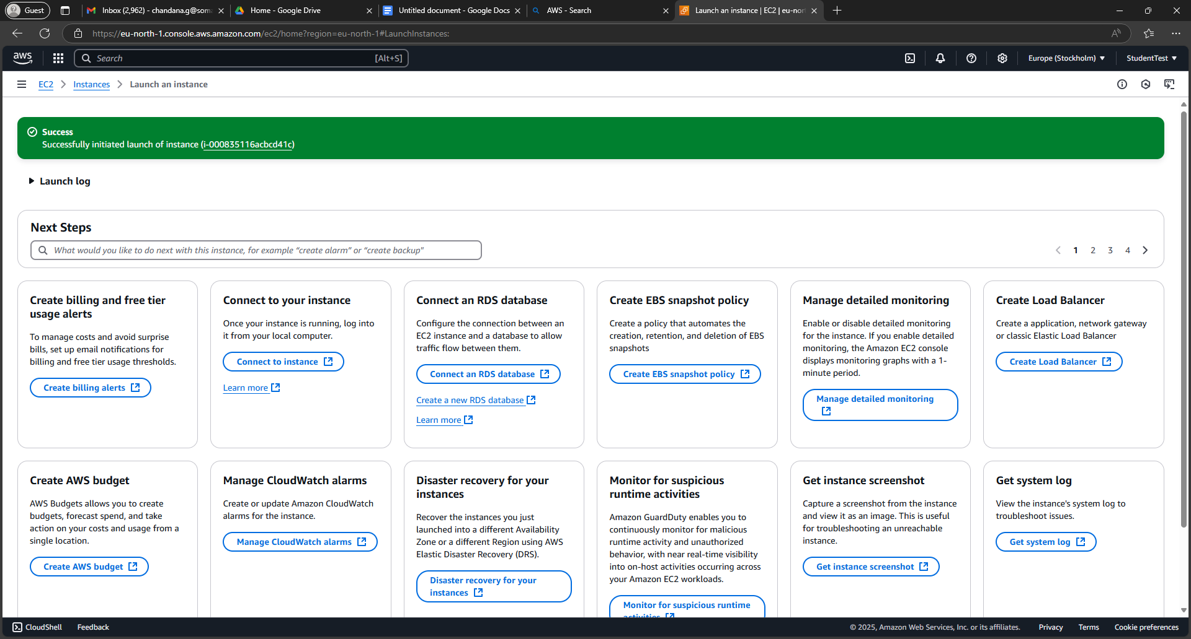

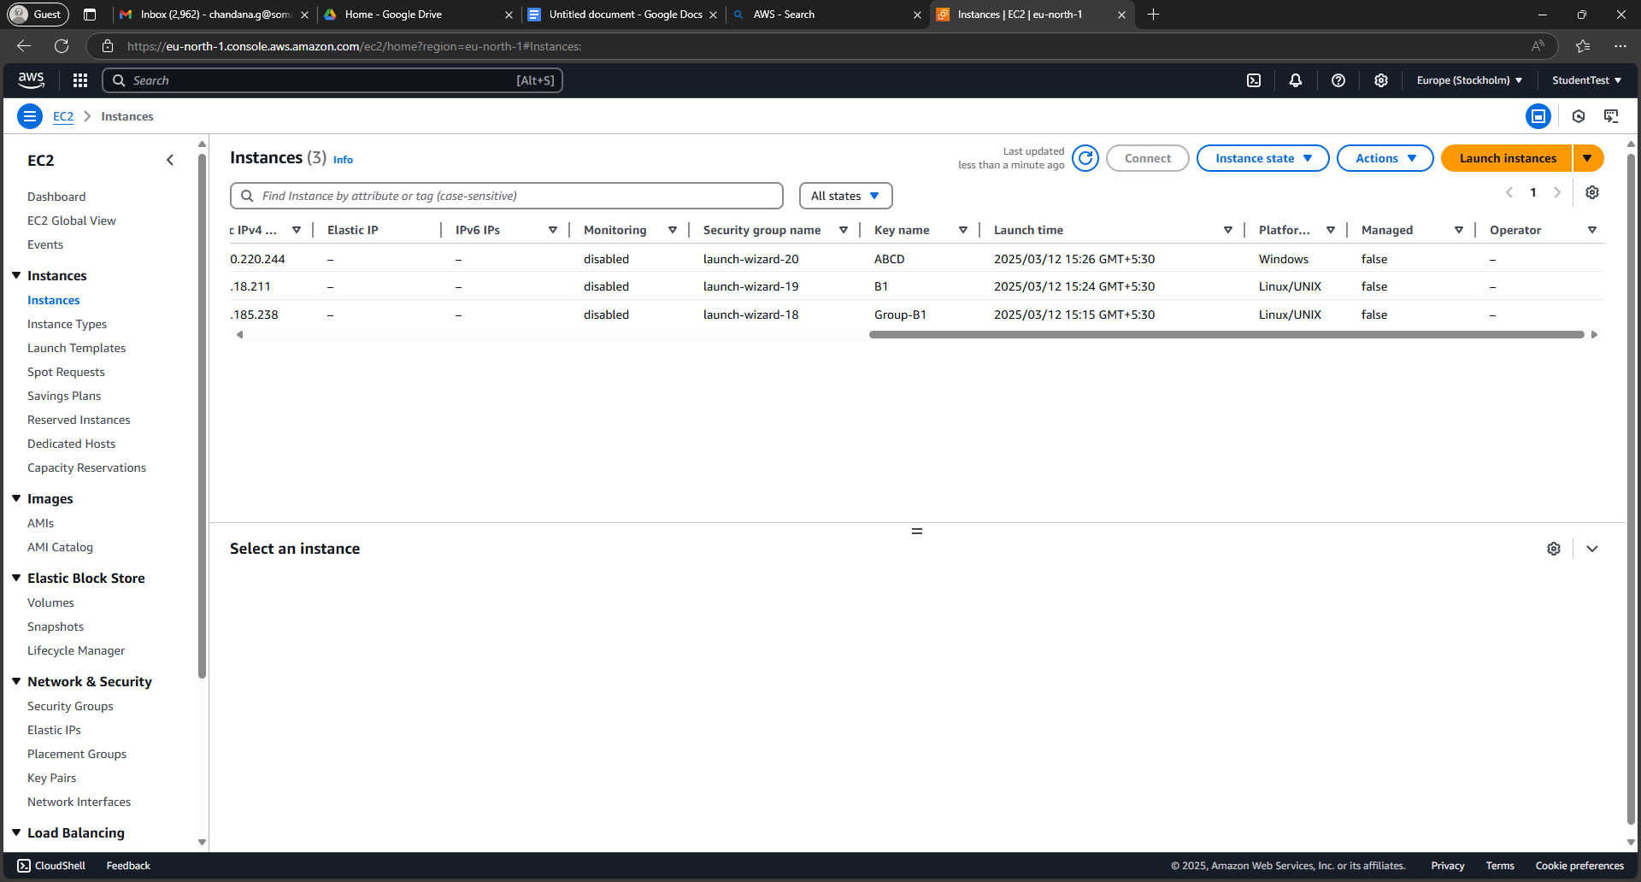

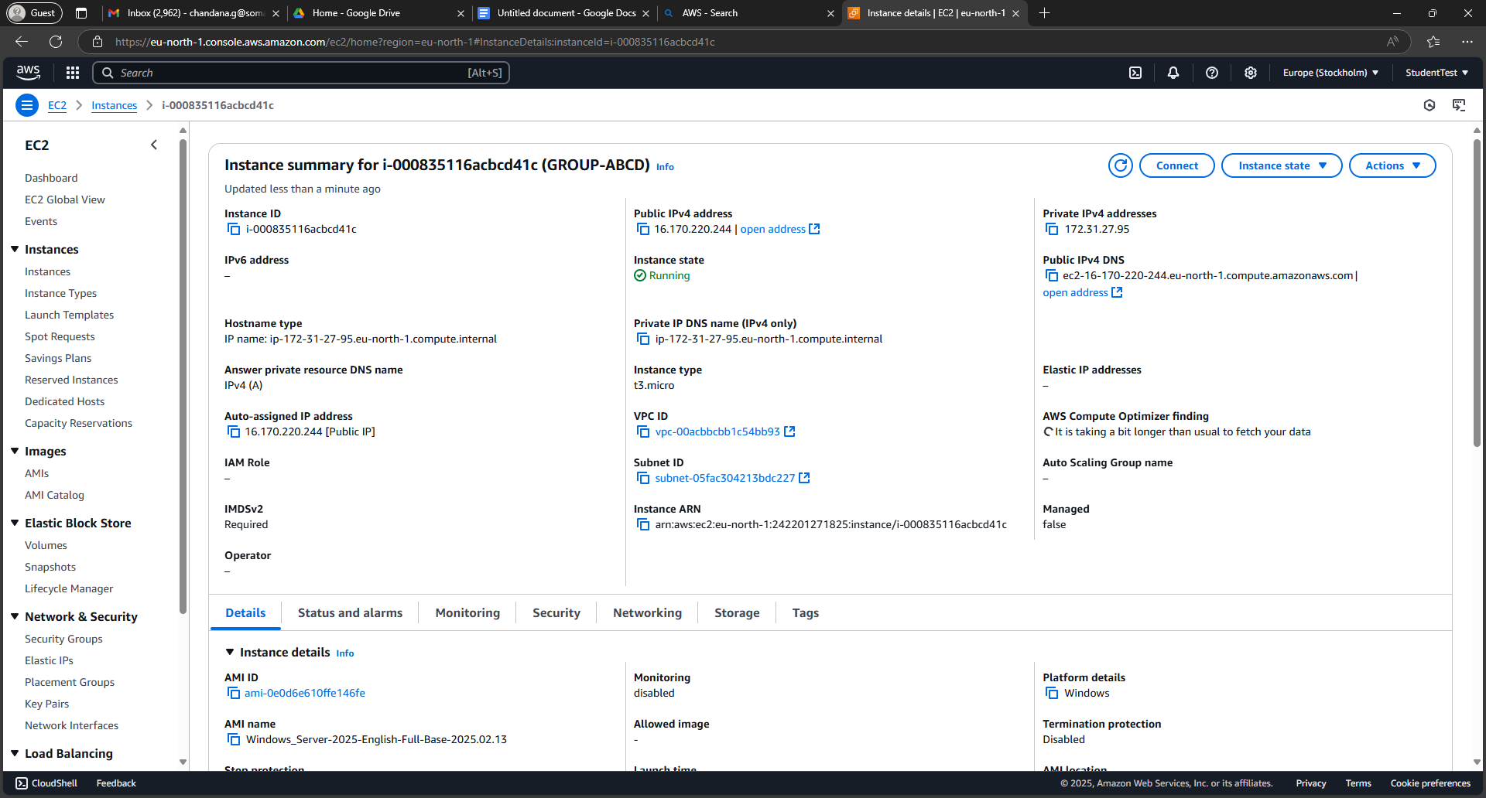

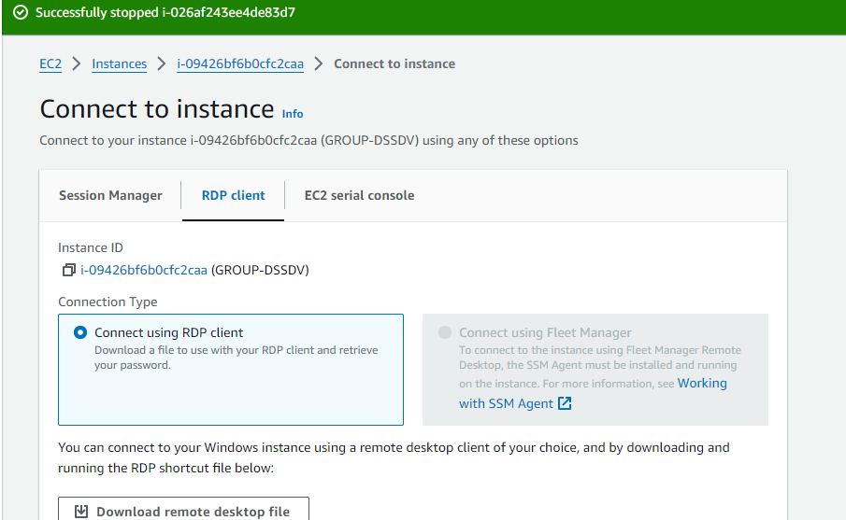

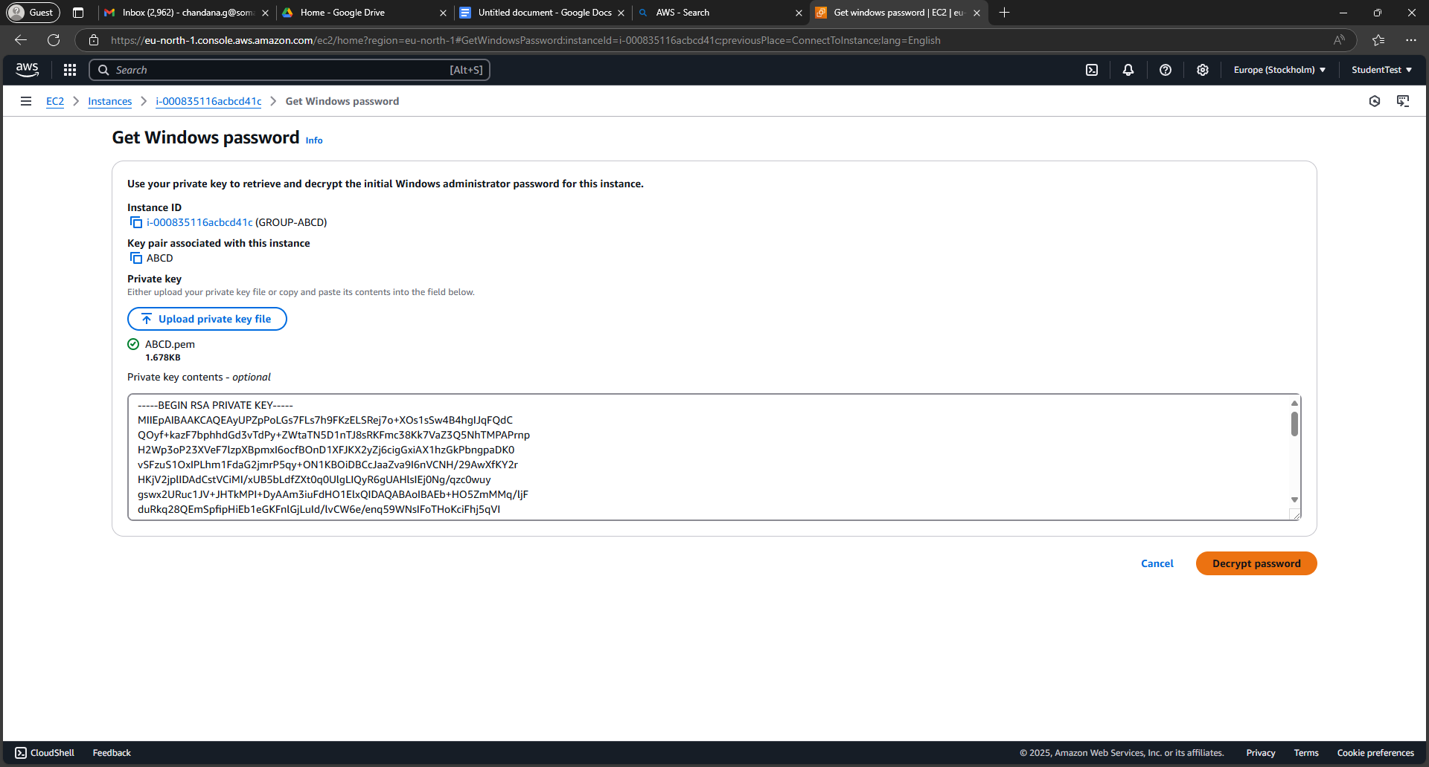

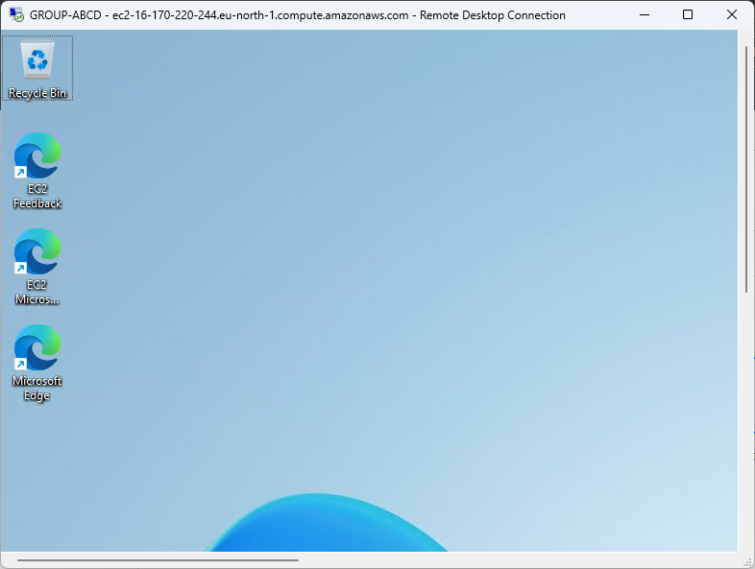

**Linux Virtual Machine (VM) instance in AWS**

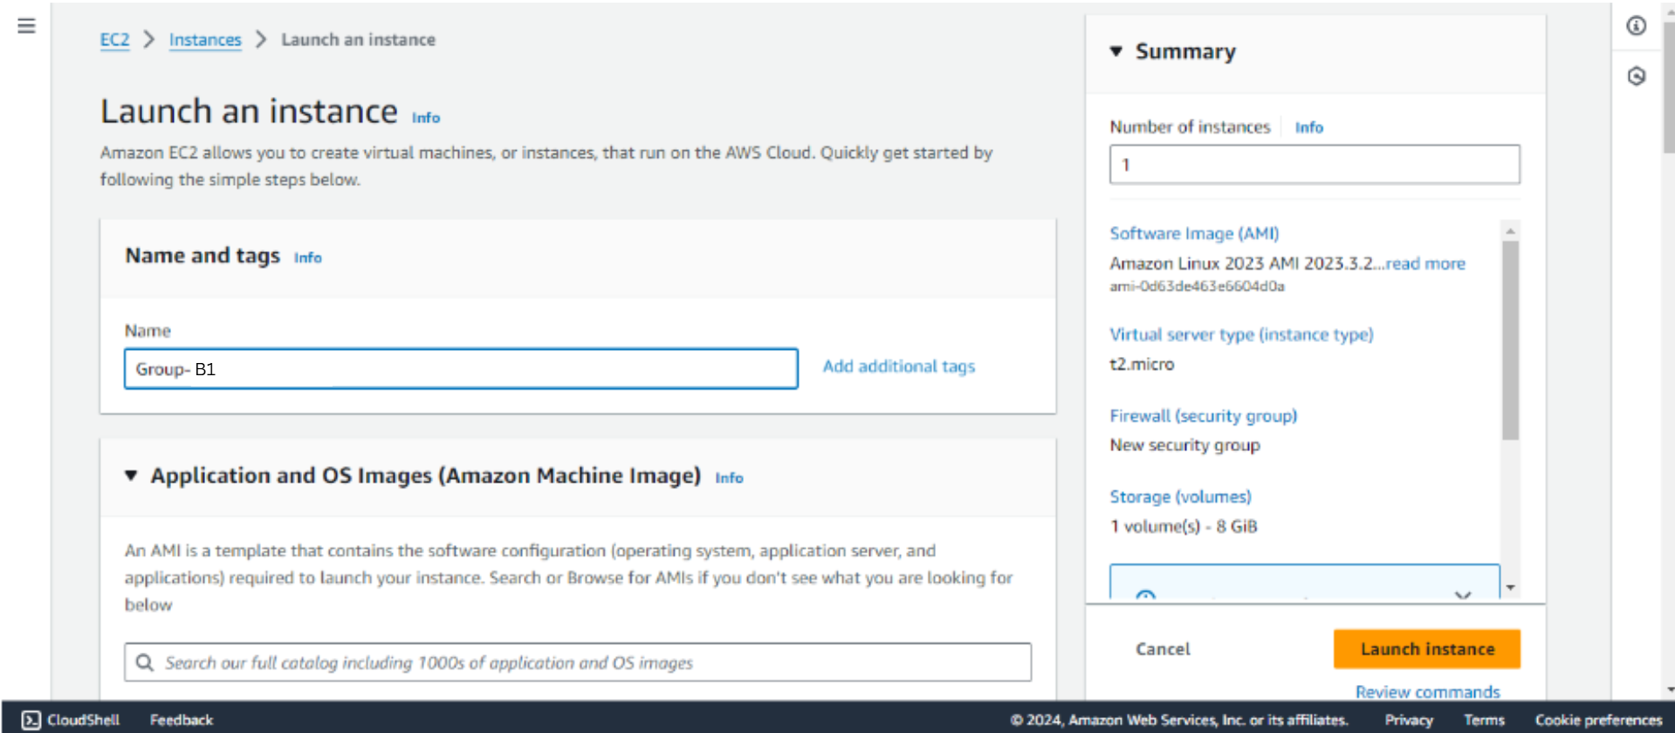

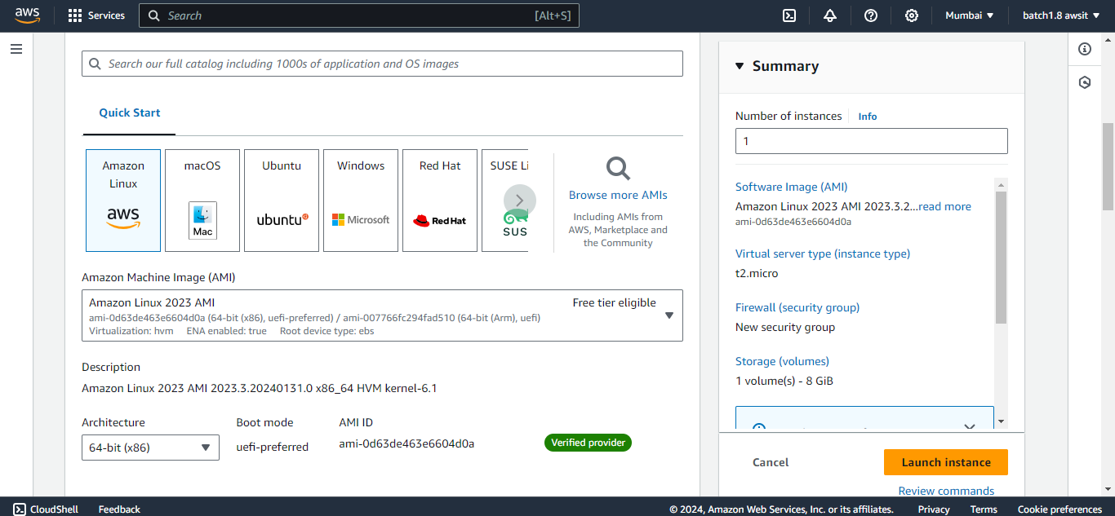

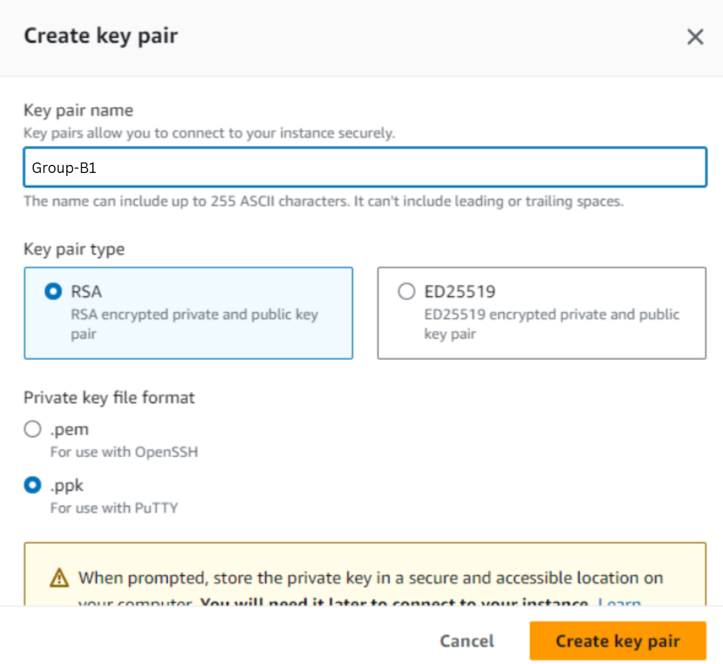

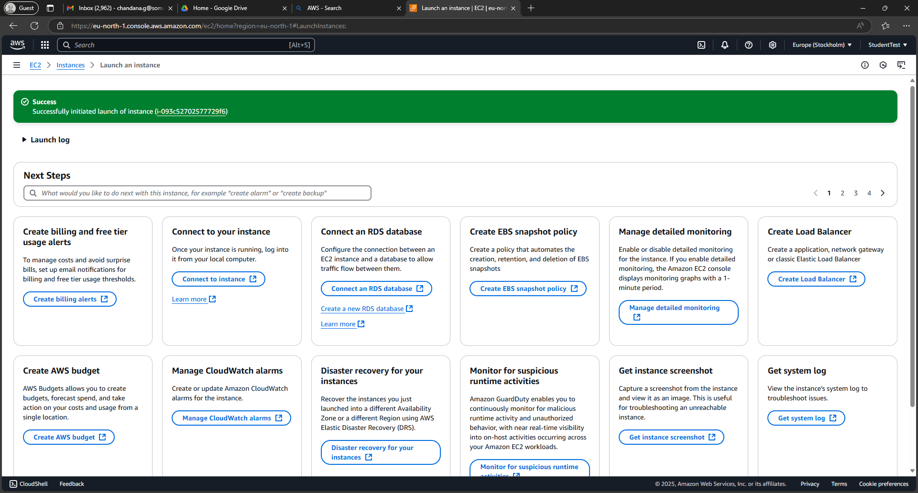

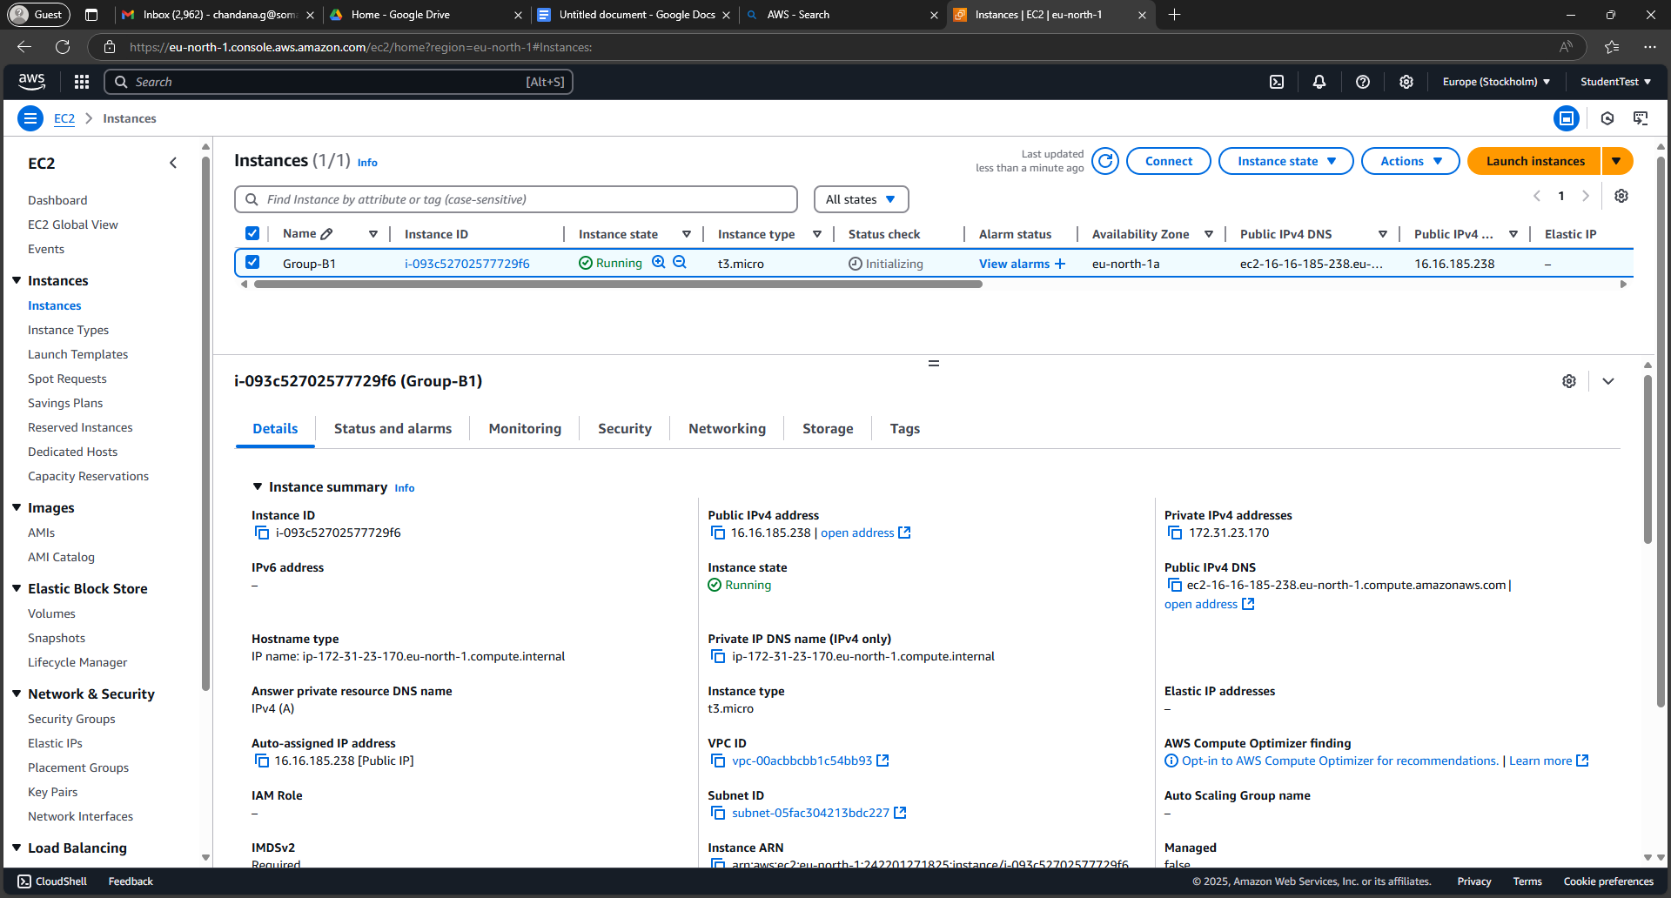

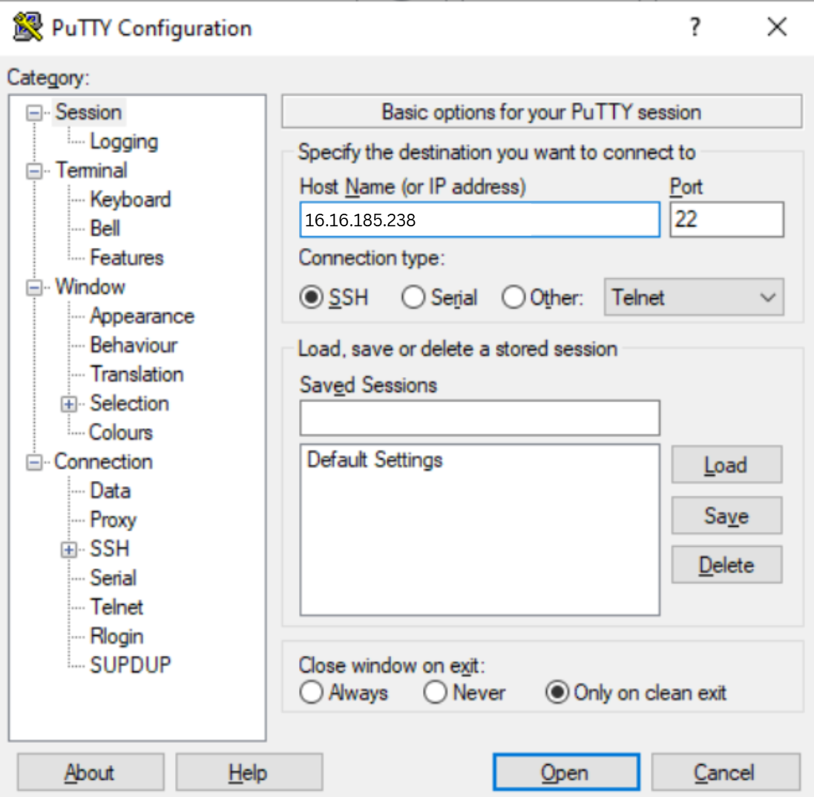

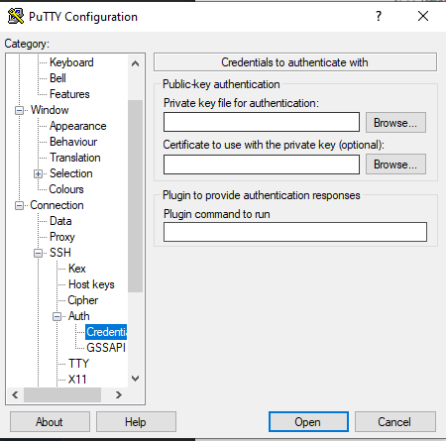

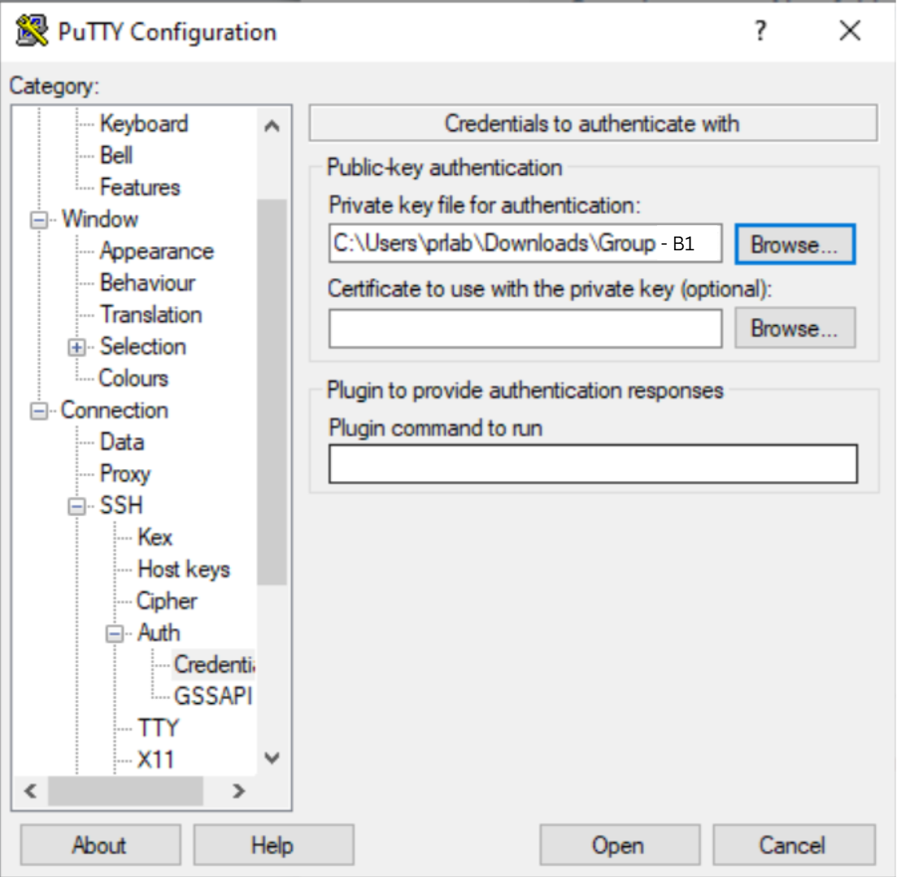

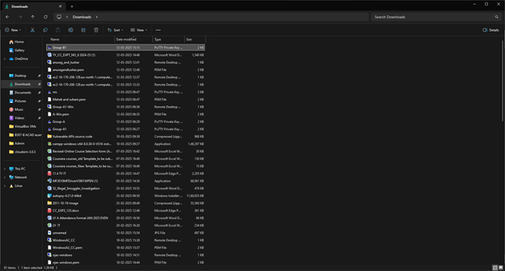

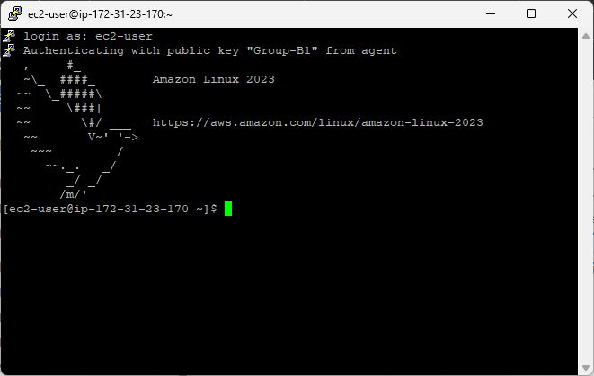

**__________________________________________**

**Questions:**

**(1) Explain two examples of each IaaS, PaaS and SaaS services.**

**1. Infrastructure as a Service (IaaS)**

IaaS provides virtualized computing resources over the internet, such as servers, storage, and networking.

* **Amazon Web Services (AWS EC2) –** AWS Elastic Compute Cloud (EC2) provides scalable virtual servers, allowing businesses to host applications and manage their own infrastructure.
* **Google Compute Engine (GCE) –** Offers virtual machines on Google's infrastructure, enabling users to deploy, manage, and scale applications without investing in physical hardware.

**2. Platform as a Service (PaaS)**

PaaS provides a development platform with tools and services needed to build, test, and deploy applications.

* **Google App Engine –** A fully managed platform that allows developers to build and deploy applications without managing the underlying infrastructure.
* **Microsoft Azure App Services –** Provides a cloud-based environment for hosting and managing web applications, APIs, and mobile backends with built-in scaling and security features.

**3. Software as a Service (SaaS)**

SaaS delivers fully developed software applications that users can access via a web browser without installing anything on their devices.

* **Google Workspace (Gmail, Docs, Sheets) –** A suite of cloud-based productivity tools that allow users to collaborate in real time.
* **Salesforce –** A cloud-based customer relationship management (CRM) software used by businesses to manage sales, customer support, and marketing automation.

**__________________________________________**

**Outcomes: CO2 — Study the Evolution of Cloud Computing and its models**

**__________________________________________**

**Conclusion: (Conclusion to be based on the objectives and outcomes achieved)**

This experiment demonstrates the creation of both Windows and Linux virtual machines (VMs) on AWS, utilizing RDP for accessing the Windows instance and SSH via PuTTY for accessing the Linux instance. AWS EC2 instances provide flexible, on-demand compute resources, allowing users to run applications on both Windows and Linux environments remotely. By using RDP for graphical access to the Windows instance and SSH with PuTTY for Linux, users can effectively manage both operating systems in a secure and scalable cloud environment. Additionally, the direct download of .pem and .ppk files from AWS simplifies the setup process without requiring conversion, ensuring efficient access to the virtual machines.

**__________________________________________**

**Grade: AA / AB / BB / BC / CC / CD / DD**

**Signature of faculty in-charge with date**

**__________________________________________**

**References:**

**Books/ Journals/ Websites:**

1. <https://azure.microsoft.com/en-us/free/students/>

**__________________________________________**